SDT Ez-meter installation
- Install the communication cable of Ez-meter
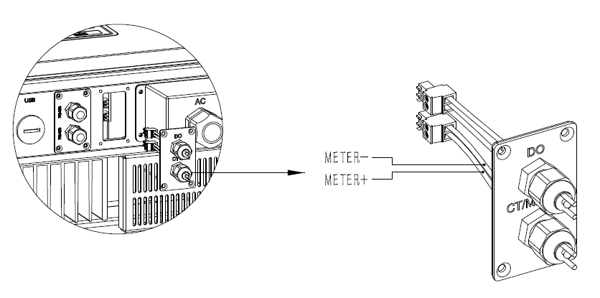
B. Install the power cable of Ez-meter
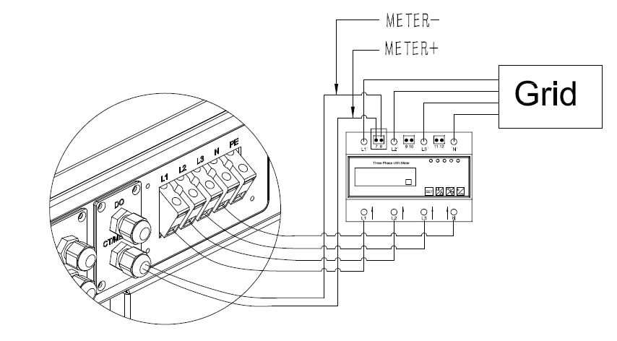

C. Set the Power limit
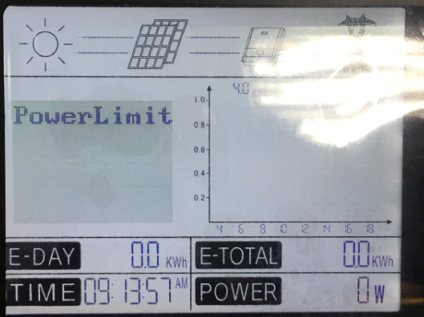
Long press the enter button to set the power limit.
Long press the enter button to turn on the Power Limit function. ”Up” and “Down” to set the power limit value. (Range is 0%-100%)
